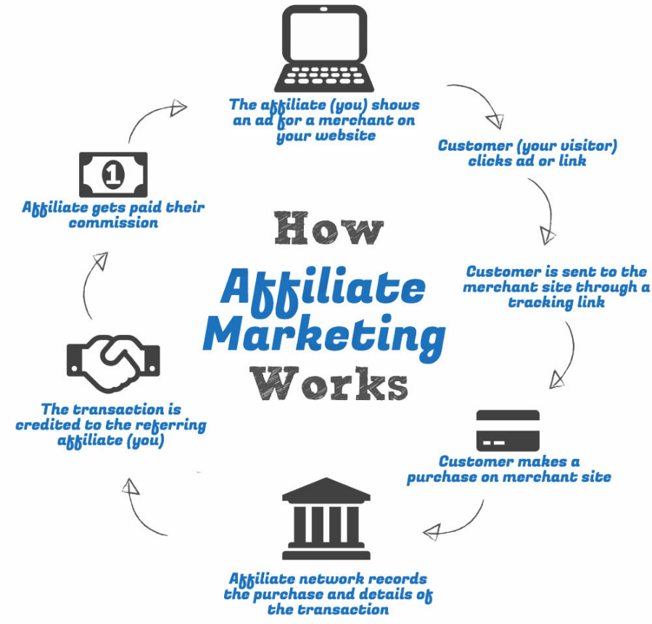
Copyright © All rights reserved worldwide.

YOUR RIGHTS: This book is restricted to your personal use only. It does not come with any other rights.

LEGAL DISCLAIMER: This book is protected by international copyright law and may not be copied, reproduced, given away, or used to create derivative works without the publisher’s expressed permission. The publisher retains full copyrights to this book.

Internet Visions Defined has made every reasonable effort to be as accurate and complete as possible in the creation of this book and to ensure that the information provided is free from errors; however, the author/publisher/ reseller assumes no responsibility for errors, omissions, or contrary interpretation of the subject matter herein and does not warrant or represent at any time that the contents within are accurate due to the rapidly changing nature of the Internet.

Any perceived slights of specific persons, peoples, or organizations are unintentional.

The purpose of this book is to educate and there are no guarantees of income, sales or results implied. The publisher/author/reseller can therefore not be held accountable for any poor results you may attain when implementing the techniques or when following any guidelines set out for you in this book.

Any product, website, and company names mentioned in this report are the trademarks or copyright properties of their respective owners. The author/publisher/reseller are not associated or affiliated with them in any way. Nor does the referred product, website, and company names sponsor, endorse, or approve this product.

COMPENSATION DISCLOSURE: Unless otherwise expressly stated, you should assume that the links contained in this book may be affiliate links and either the author/publisher/reseller will earn commission if you click on them and buy the product/service mentioned in this book. However, the author/publisher/reseller disclaims any liability that may result from your involvement with any such websites/products. You should perform due diligence before buying mentioned products or services.

This constitutes the entire license agreement. Any disputes or terms not discussed in this agreement are at the sole discretion of the publisher.

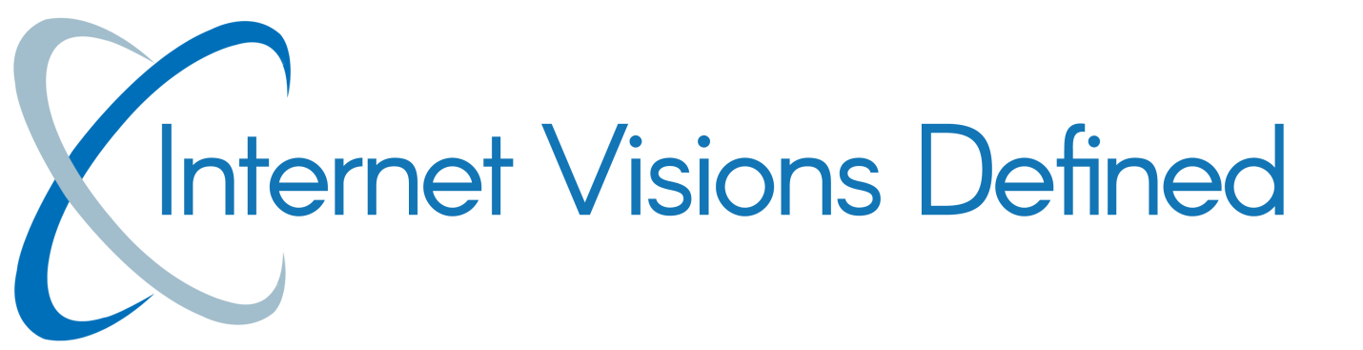

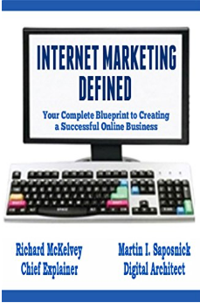

Training Series # 26
Affiliate Marketing Advantage

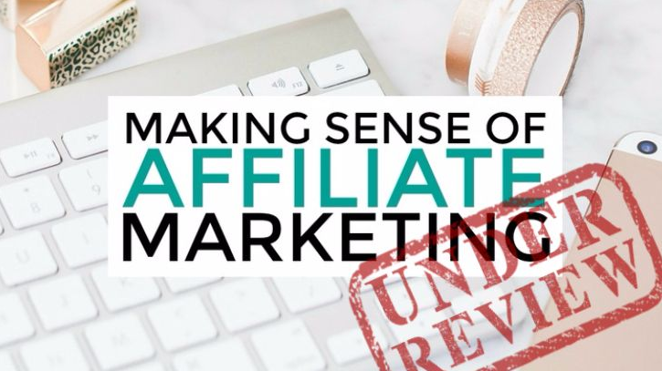

Table of Contents

Introduction 4
Connect, Entice, Convert 6
Bribe Your Way To The Bank 10
Creating Killer Bonus Content 13
Instant Bonus Packages 18
Final Words 20
Resources 21

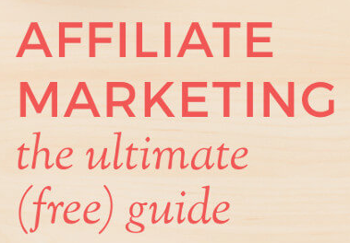
Introduction
If you want to stand out in the affiliate marketplace, maximize your income quickly while building a list of ultra-targeted, loyal customers, then you will want to read every word in this special report.
Internetvisionsdefined.com has the most comprehensive training modules located on our site, taking you from the very beginning to the master affiliate stages of affiliate marketing.

You see, many new affiliate marketers get it all wrong. They complicate the process of turning prospects into customers by failing to connect, entice, and funnel their traffic in a way that converts.

And that’s what it’s all about, right? As an affiliate marketer, your main objective is to warm up a customer base and turn those prospects into buyers. And not just buyers who will purchase products through your affiliate links, but customers who will turn to you time and time again, when they are making the decision to purchase. (aka EVERGREEN).
The great news is that it’s easier to do than you may think.

There are a couple of incredibly powerful strategies that can change the way you promote products so that you are instantly maximizing not only your outreach, but your bottom line. Doing this will catapult your efforts, and land you at the top of the affiliate leaderboards.

And that’s what this report was designed to do – it will teach you exactly how to go from new (or even intermediate) affiliate marketer to super affiliate in just a matter of a few short weeks.

So, without further delay, let me show you how you can break through the prospect-to-customer barrier and generate unstoppable sales, 24-7 – all without having to spend a lot of time, or money building sustainable affiliate campaigns.

Are you ready to absolutely dominate the leaderboards and see your name at the very top?

Good! Then let’s get started!

Connect, Entice, Convert

When it comes to turning a prospect into a customer, there are 3 important steps in the process:

Connect, Entice and Convert.
Here’s exactly what we mean:
Connecting with your target audience means much more than simply getting them onto your mailing list, or funneling them to your website or sales system. It also requires more than just a couple of quick emails sent out through an autoresponder sequence.

The top affiliate marketers – every one of them – all have one thing in common: they know exactly how to connect with their audience on a personal level, and they’re willing to go the extra distance – further than the competition does.

That doesn’t mean they spend hours of their time crafting personalized emails, or doing the back-breaking work of one-on-one conditioning. You can still easily connect with your target audience in a way that demonstrates your commitment to them without having to sacrifice every second of your spare time catering to individuals with a thousand questions or concerns.

It all begins with how you meet your prospect. This means that every element in your sales system needs to be tweaked so that it speaks directly to your target audience and demonstrates clear value.

From your landing page, squeeze page, sales page (if you sell products yourself), to your email campaigns, you need to know who your demographic is so that you can create compelling content that not only is share-worthy, but speaks to your market as though you are a friend guiding them every step of the way through every purchase decision they make.

You see, positioning yourself as someone who is looking out for your customer will set you head and shoulders above the competition. You know the kind of affiliates I’m talking about – the ones who shovel dozens of emails into the faces of their audiences with little regard to whether the products or services they are promoting will ever improve the lives of their prospects.

You’ve probably been on several lists of affiliates just like that, and if you’re anything like me, you couldn’t get off those email lists fast enough.

They come across as hard sellers, rugged marketers who are only looking out for one person: themselves. And this becomes crystal clear to anyone who follows their methods long enough. That’s why they have to work so hard to constantly recruit new customers! Because they quickly burn their lists out and are forced to rebuild time and time again.

Even brand new customers who may not be as savvy with Internet Marketing tactics will quickly discover that these affiliate marketers don’t have their back and will ultimately abandon them.

Don’t be that kind of affiliate marketer. Instead, look for ways to design your emails and landing pages around what best serves your prospects. Speak their language, touch down on what’s most important to them and above all else, offer them incredible value. Earn their trust, and you’ll earn their loyalty.
This is why at Internet Visions Defined we have created an accountability protocol. We want to have your back.
Our goal is to have you “be in business for yourself, but not by yourself”.
We solely exist to make sure you make money, because when that happens, we make money also. It is as simple as that.
And that’s the ultimate connection that you want to make.

Enticing your prospect involves knowing what makes them tick, what their most interested in, and what they are looking for. Offer that to them and you’ll break through all barriers and earn that commission time and time again. We’ll talk more about the easiest ways of enticing prospects and winning that sale in just a few minutes.

Converting a prospect into a customer happens automatically when you’ve connected and enticed. If you’ve done your job at earning trust, and persuading that prospect that you have exactly what they need to improve their life in some way, you’ll see an immediate increase in conversion rates across the board.

Bribe Your Way To The Bank

When we talk about bribing prospects, we don’t mean that you offer something that’s too good to be true and then fail to deliver. We also aren’t talking about compensating them for purchasing through your affiliate link in a way that takes money out of your pocket.

On the contrary, we are talking about “ethical bribery”, where you offer your prospects additional value – for free – just for purchasing through your link.

So, what kind of ethical bribes will work for your market?

It all comes down to the kind of products you are promoting, and how you can best tie your bonus product into an existing sales funnel.

For example, if you are promoting a course that teaches people how to build mailing lists, you could create a series of email squeeze page templates that are offered as a bonus product. This kind of bonus ultimately extends the value of their purchase, provides a done-for-you template that eliminates their workload, and simplifies the process.

It’s a direct tie-in to the main product you are promoting without taking away from what that product offers.

This also means that you never want to create a component that is already part of the main package that you’re promoting. Always strive to offer something not already included, as well as a bonus item that enhances the value.

You want the benefit to be clear to anyone who is considering purchasing through your links, letting them know why they’re making a smart decision by buying through you. Never hide the fact that they are buying through your link.

Your bonus offer should always be exclusive to your own marketing and limited in nature, meaning that you offer it only to the audience you are targeting for each individual product. While you could offer the same bonus to multiple groups of people, it’ll decrease its perceived value if you have any sort of cross-over within segments of your audience.

This means that if you want to repurpose the bonus package so that you can offer it within multiple campaigns, you should consider adding something different to the offer so that it isn’t exactly the same.
(See our tutorials on creating campaigns).

Make it unique in some way – whether that comes from adding a bit more value, an extra report or template, or a component that isn’t included anywhere else, the idea is to create high-value bonus offers that your audience doesn’t already have, and won’t see from another affiliate marketer.
That way, if you end up promoting the same bonus to someone who has already received it from a previous purchase, they are still getting something new that they haven’t already received from you.

In the next chapter, we’ll look at the kinds of bonuses you should consider when working on your promotional campaign, and what is best suited for different markets.

Creating Killer Bonus Content

The one thing that many new affiliate marketers struggle with is exactly what kind of bonus content will entice and convert prospects into becoming customers.

The truth is, the better you know your market, and the easier it will be to create bonus products that appeal to the masses. There’s no getting around it; you should know what they are most interested in so you can capitalize on that when creating your bonus or auxiliary components.

So, begin by researching your niche. Look for what kind of products are actively being sold, and are still in demand, and then create a bonus package around that medium.

Scour niche-related forums; explore social media, as well as your favorite online marketplaces (primarily the ones you plan to use within your affiliate marketing campaigns) such as JVZoo.com or ClickBank.com.

For example, if you are in the weight loss niche and are promoting a fitness membership site that provides videos, work-outs and healthy eating meal plans, consider creating a short recipe booklet that offers additional recipes for that specific crowd (low-carb, fat-free, keto, etc.).
The key is to ensure your bonus offer extends the value of the product you are promoting, while not competing with it.

Here are a few ideas to get you started:
Coupons
In today’s economy, everyone is looking to save money and snag a great deal. Consider offering coupons on other products or services in your niche. And you don’t have to offer them to everyone. Instead, consider creating special coupons for early birds or fast-action takers. Not only will this reward those who act quickly, but it will implement a sense of urgency into your offer. See below instruction. (https://www.youtube.com/watch?v=B65H8JMZVjA)

Loyalty Program
Some of the top affiliate marketers have created a loyalty program that acknowledges repeat customers and rewards them for their continued business. You could easily set something like this up within your affiliate marketing campaigns easily just by keeping a database of customers who have proven to have purchased via your links in the past. Send them out an email after so many purchases and offer them something special and unique to the program.

Video Training
People love videos, especially when purchasing training material or information that requires them to follow a system in order to see results. Consider creating additional video content based around the primary product you are promoting and offer it to those who purchase through your links.

Host a Webinar
Consider hosting a Webinar in order to provide additional information about the products you are promoting. Not only will this help to warm up your audience, but it’ll help you build a recognized brand in your niche while being able to directly connect and communicate with your target audience.

Write Detailed Reviews
There is nothing more powerful in a sales funnel than a well-written, detailed review that outlines everything a potential buyer should know about a product. People who are on the fence about spending their hard-earned dollars need as much information as possible. They want to be reassured and to know that the products they purchase are authentic, and will help them achieve results.

So, you should always write a comprehensive, in-depth review for any product you plan to promote. Host it on your blog and direct people to it from social media, paid ads and of course, your mailing list.
Reviews are considered bonuses because they help educate and inform prospects into making sound buying decisions. Not every affiliate marketer will make the effort to write reviews for the products they are promoting so doing this will help to set you apart from the competition. People will thank you for it!
Case Study
If you want to take things a step further and you’ve found success with the product yourself, create your own case study and show potential customers what the product did for you (and how it can work for them, too). Case studies are powerful marketing tools that help educate people while reassuring them that the product does as it promises.

Access to Free Membership Sites
One of the best ways to entice customers into purchasing through your affiliate links while building a brand and community of your own is by providing free access into a membership-style website.
This website serves as the hub for all of the tools and resources you have to offer, and it’s also a great way for you to stay in contact with your audience while building a name they can trust.

You can choose to build a membership site yourself using tools provided on our site or purchase rights to pre-made membership websites that you can sell access to, learn about this at: https://internetvisionsdefined.com

Instant Bonus Packages

If you’re short on time and aren’t sure how to get started, there’s an easy way to create bonus offers that your customers will love while minimizing your workload. Sign up for an account at https://commissiongorilla.com and let them do the work for you.

In fact, with this one resource you won’t have to lift a finger as you’ll have instant access to 10 done-for-you bonus packages that you can use to turn prospects into customers!
We have personally used Commission Gorilla to create dozens of hot affiliate bonus products while taking advantage of their drag & drop bonus builder that provides 4 different layouts for you to choose from. Their system is very user-friendly and you can create as many bonus products as you like within minutes.

We also use Commission Gorilla to create our bonus pages as they are easy to customize and saves a ton of time. You can simply drop in your on-page elements; choose the bonuses you want to feature from your library and save the page. All changes are instantly reflected as well, so you can modify elements on the fly.
And as you know, promoting your pages is where the money’s at. With a service like Commission Gorilla, you’re given access to their built-in social media sharing options which means you can immediately broadcast your offer to all your followers and friends, jump-starting traffic instantly.

In addition, Commission Gorilla also creates your bonus download page automatically so all you have to do is direct your buyers to this page, providing them with immediate access to your offers.
It’s the fastest and easiest way to create attractive bonus offers and pages in just minutes. Check it out: https://commissiongorilla.com/v2/

Final Words

The best bonuses are even more valuable than the product itself. Your offer should demonstrate clear value and be an absolute no-brainer to those who are considering purchasing through your link.

Always work towards creating a bonus offer that enhances the value of the product being sold, and limit distribution whenever possible. Make the offer unique and special in some way, and whenever possible, exclusive to your offer.
Private label websites are a great place to source content that you could turn into high-quality bonus offers, but consider combining multiple private label products together to create something new.

Reports, interviews, webinars, eBooks and video training are all highly sought after bonus items that will maximize the value of your customers purchase while making it easy for you to stand out in the affiliate marketplace.

Resources

Here are links to the resources found in this guide.

Automated Bonus Offers:
>> https://commissiongorilla.com

Private Label Content For Bonus Offers:
>> http://www.internetvisionsdefined.com

Membership Software / Product Protection:
>> https://www.ProductDyno.com

To your success, Rich and Marty

